JAVASCRIPT

Accessing DOM elements

Objectives
In this exercise you will learn how to access DOM elements using code

Reference material
This lab is based on material from the “Accessing DOM elements” chapter.

Part 1: Add Items to a List Dynamically
Create a web page where the user can enter a task into a text field and click a button to add that task as a new <li> element in an unordered list (<ul>).
A sample starter HTML is offered at the end of this document.
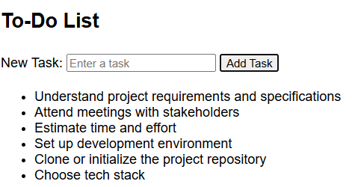
- Create a text input for entering a task description.
- Add a button with label of “Add Task”.
- When the button is clicked:
  - Read the input value.
  - Create a new <li> element.
  - Set the text content of the <li> to the input value.
  - Add the new <li> to the end of the <ul>.
- Run and test your code

Part 2 - Changing CSS
- Change your code and HTML to set status for each task.
Something like:
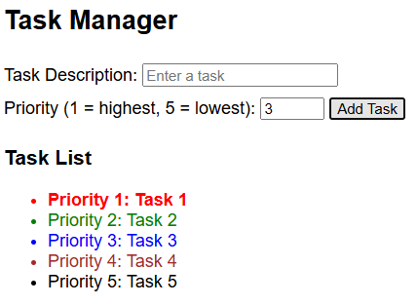
A sample starter HTML page with style is offered at the end of this document. Feel free to change the style, like adding borders.
- Copy your code from part one and change the style of each new task depending on its priority.

To-do list starter page:
<!DOCTYPE html>
<html>
<head>
<title>Tasks</title>
<style>
body {
font-family: sans-serif;
}

input, button {
margin: 5px 0;
}
</style>
</head>
<body>
<h2>To-Do List</h2>

<label for="taskInput">New Task:</label>
<input type="text" id="taskInput" placeholder="Enter a task">
<button onclick="addTask()">Add Task</button>

<ul id="taskList"></ul>

<script>
function addTask() {
// Create a new <li> element
// Add it to the <ul>
// Clear the input
}
}
</script>
</body>
</html>

Tasks with priority
<!DOCTYPE html>
<html>
<head>
<title>Tasks</title>
<style>
body {
font-family: sans-serif;
}

label, input, button {
margin: 5px 0;
}

.priority-1 {
color: red;
font-weight: bold;
}

.priority-2 {
color: green;
}

.priority-3 {
color: blue;
}

.priority-4 {
color: brown;
}

.priority-5 {
color: black;
}
</style>
</head>
<body>
<h2>Task Manager</h2>

<label for="taskInput">Task Description:</label>
<input type="text" id="taskInput" placeholder="Enter a task"><br />

<label for="priorityInput">Priority (1 = highest, 5 = lowest):</label>
<input type="number" id="priorityInput" min="1" max="5" value="3">

<button onclick="addTask()">Add Task</button>

<h3>Task List</h3>
<ul id="taskList"></ul>

<script>
function addTask() {

}
</script>
</body>
</html>

